**LIN Fengmian 林風眠 (1900-1991)**

Lin Fengmian was a twentieth-century Chinese artist who introduced Western modernism into the Chinese art scene through both his painting practice and teaching activities. In 1919, Lin joined a Chinese work-study program and spent the next six years studying art in Europe. He was influenced by modernist styles including Fauvism, Cubism and Expressionism. During this formative phase, his belief in Western and Eastern artistic synergy started to form. His monumental canvases from this period echoed the large expressionistic paintings from his German days, in which a profound sense of humankind’s malaise and struggle can be observed. His more formalist oils, with their spatial fragmentation and angular shapes, paid homage to Cubism, while his ink and watercolour paintings employed devices of foreshortening and shading. His mature work is characterized by a hybrid of painting media, a rich palette, layering of heavily hued areas, and simplified line and form that induce lyrical and naïve qualities. As an art instructor, Lin promoted Western-style art and pedagogy. He taught a number of Chinese modern artists, including Li Keran 李可染 (1907-1989), Wu Guanzhong 吳冠中 (1919-2010), and Zao Wou-ki 趙無極 (1921-2013).

Born into a craftsman’s family, Lin Fengmian pursued his interest in art whilst on government scholarship abroad in the early 1920s. He entered the Écoles des Beaux-Arts in Dijon and Paris, and was a pupil of Fernand Cormon (1845-1924). He traveled to Berlin for a year, where his works gained philosophical depth. His paintings were exhibited at the Salon d’Automne and elsewhere in Europe. Upon returning to China, Lin served as the first director of the national art academy in Hangzhou founded in 1928, where he was instrumental in implementing a modern art curriculum and recruiting of foreign or foreign-trained instructors.

When the Sino-Japanese war began in 1937, Lin led the Hangzhou academy’s inland retreat. His oil paintings were left behind and subsequently destroyed by Japanese bombing. He taught intermittently until 1952 when he moved to Shanghai. During the Cultural Revolution (1966-1976), he suffered severely when another large group of his works were destroyed before he was able to move to Hong Kong in 1977. After the war Lin’s oil paintings gave way to paintings in a mixture of ink, gouache, watercolour, and Chinese painting pigment on square sheets of paper. His fascination with light effects is evident in the luminescent washes in his landscapes and the suggestion of interior illumination in his still lives. He often depicted autumnal scenes, which embody an air of melancholy. In figure painting, the stylised female poses may have been derived from Matisse or Modigliani, but the sinuous line is highly evocative of the Chinese brush. He also painted Chinese opera figures.

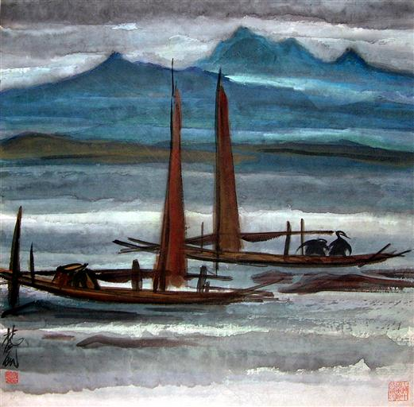

Lin Fengmian. *Jiang shang* 江上 (Scenery On the River). Ink and colour on paper. 67.5 x 67 cm. 1940s.

<http://china.artmuseumonline.org/CollectionExhibit/OpDetail.aspx?opid=33634e22fc3f448ab6de5820990f35f2&Filter=1&opage=1&IsClassical=1&urlP=initial%3a%2522L%2522&index=108>

**References and further reading**

--- (1999) *Lin Fengmian zhi lu* 林風眠之路 (The Approach of Lin Fengmian). Hangzhou: Zhongguo meishu xueyuan chubanshe.

---(2007) *A Pioneer of Modern Chinese Painting: The Art of Lin Fengmian* 世紀先驅：林風眠藝術展. Hong Kong: Hong Kong Museum of Art.

Zheng Chao, ed. (1995) *Lin Fengmian yanjiu wenji* 林風眠研究文集 (Lin Fengmian in Perspective). Hangzhou: Zhongguo meishu xueyuan chubanshe.